First Program in C++

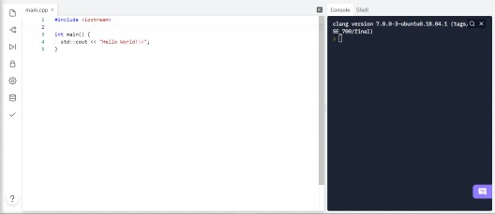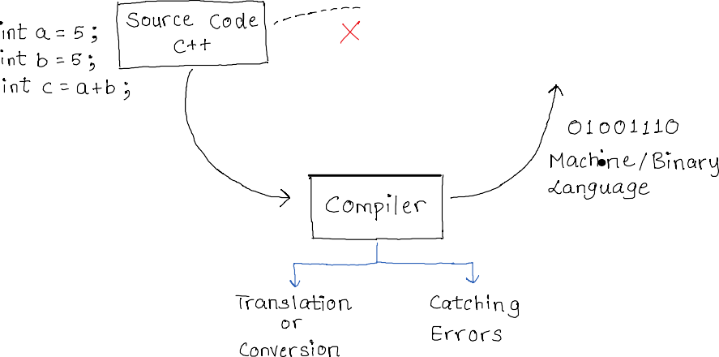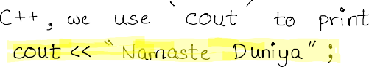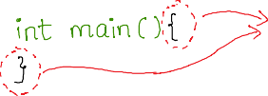

04 January 2022 20:53

[More about scope of a function](https://stackoverflow.com/questions/11345631/what-does-scope-of-functions-mean#%3A~%3Atext%3DMost%20objects%20and%20functions%20have%2Cthe%20function%20name%20is%20declared)

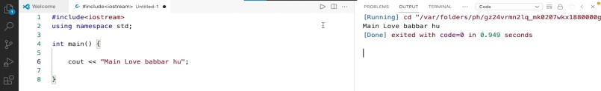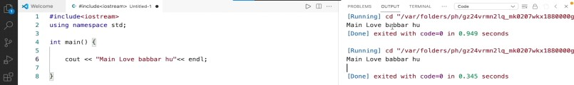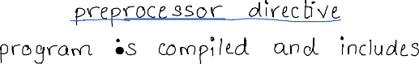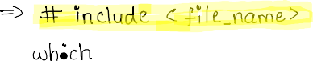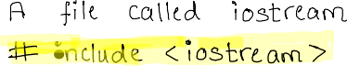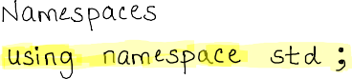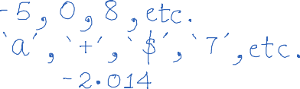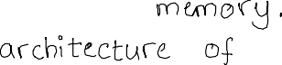

[Stack Overflow Question](https://stackoverflow.com/questions/18914106/what-is-the-use-of-using-namespace-std?lq=1)

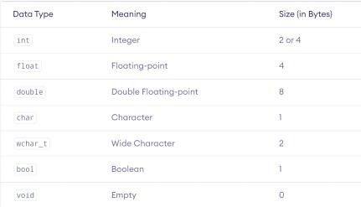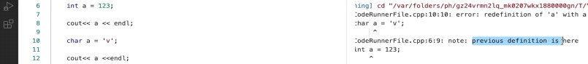

[Source: Programiz](https://www.programiz.com/cpp-programming/data-types)

[Know more about C++ Data Types](https://www.geeksforgeeks.org/c-data-types/)

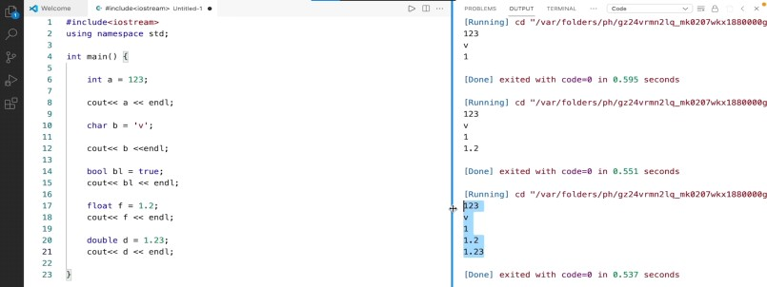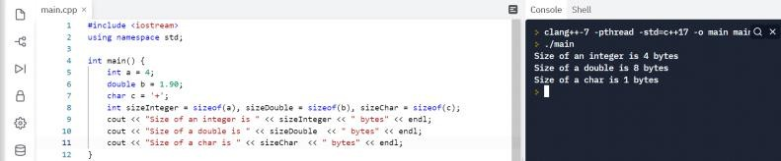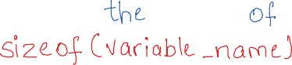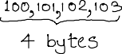

[ASCII Table](https://ascii.cl/)

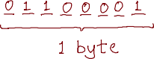

Type Casting and Storing Variables

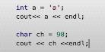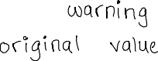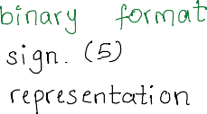

05 January 2022 17:58

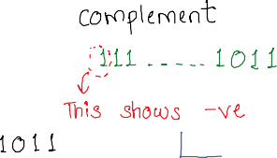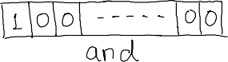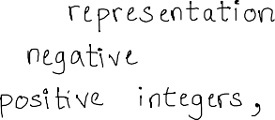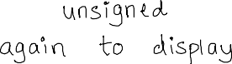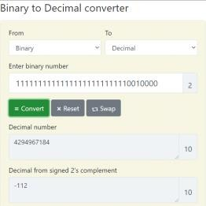

[Source](https://www.rapidtables.com/convert/number/binary-to-decimal.html)

Operators

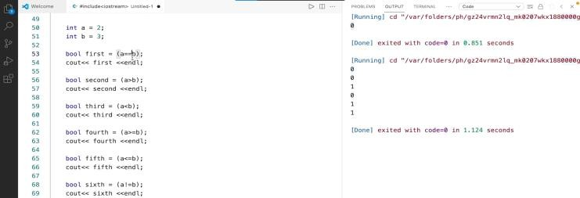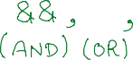

05 January 2022

19:05

